

Capstone project phase B
Coping with ADHD (attention deficit hyperactivity disorder)
(23-1-D-23)

Dr.Natali Levi

Daniel Tau - Danieltau14@gmail.com
Karin Azulay - karinazulay561@gmail.com

Table of Contents
0 Abstract………………………………………………………………………………………………………………………2
1 Description of the solution 3
1.1 The structure of the system and its operation 4
2 Description of the development process
2.1 Challenges 4
2.2 Decisions 5
2.3 Tools used 5
2.4 Interface with the client during development 6
3 Challenges and solutions 7
4 Manual 10
5 Maintenance guide 12
6 Results and conclusions 12

Abstract

This project presents the development of a web application system designed to streamline the management of pupils in elementary schools with ADHD by educators. The primary objective of this system is to provide teachers with an efficient platform to input pupil information and respond to a set of behavioral questions. Based on the gathered data, the system generates tailored treatment options that cater to the specific needs of each pupil. The implementation of the system is rooted in the Object Process Methodology (OPM), with a strong focus on ADHD learning as the central process.
During the previous capstone phase, extensive research was conducted to identify the most effective treatment options and formulate relevant behavioral questions for the web application system. This research involved a collaborative effort between the development team and our leading supervisor. The expertise and extensive research made served as valuable inputs, ensuring that the questions and treatment options included in the system were based on a solid foundation.
Moreover, the system incorporates a robust database to store and manage pupil data. This database serves as a repository for the collected information, enabling educators to access and review the pupil's profiles, behavioral responses, and generated treatment options at any time. The system empowers educators by providing a tool to allow management for its pupils, allowing them to make informed decisions and provide targeted support to pupils with ADHD.
The utilization of a structured database allows for efficient data storage, retrieval, and analysis, supporting the overall functionality and effectiveness of the system.
By combining the expertise of the development team, the insights from the collaborating supervisor, and the utilization of a well-designed database, the web application system provides a comprehensive and reliable platform for educators to manage pupils with ADHD in elementary schools.

Keywords: ADHD, treatment options, classification, behavioral questions, coping mechanisms, decision support, web application, Teacher Feedback, Teacher Assistance,Pupils,Management

- Introduction
ADHD is a prevalent issue, affecting many children and adults today. While medication is a common treatment approach, there is a need to explore alternative solutions. Attention disorders can vary based on age, gender, and the child's living environment, influencing their severity and impact.

The symptoms associated with attention deficit disorder arise from neurological problems and can be categorized into attention and concentration difficulties, hyperactivity, and impulsivity. These symptoms significantly impact an individual's functioning at home, in the community, at school, and at work. It's important to recognize that attention deficit disorder symptoms not only affect individuals with the disorder but also have broader implications for those around them.

In response to these challenges, we have developed a web application specifically designed for elementary school teachers to assist children with attention disorders. The application enables teachers to input relevant data about their pupils with ADHD by filling out a form consisting of ADHD-related questions. Based on the entered information, the application generates a customized treatment plan for each pupil. This treatment plan provides specific guidance for teachers to follow in the classroom, helping the child without disturbing other students.

The web application provides teachers with a convenient platform to manage their classrooms and pupils. They can access the application to fill out the ADHD questionnaire, which triggers the automatic generation of a personalized treatment plan.

The implemented web application empowers teachers to effectively support children with attention disorders in the classroom. By streamlining the process of generating customized treatment plans, the application enhances the teacher's ability to provide targeted assistance to each individual pupil. It offers a user-friendly interface for managing classrooms, filling out forms, and accessing treatment plans.

Description of the solution

The structure of the system and its operation
The solution is structured with a system architecture that leverages various technologies to ensure its efficient operation. The system is deployed using Heroku, a cloud platform that enables easy hosting and scalability. The front-end development is implemented using HTML, CSS, JavaScript, and jQuery, allowing for an interactive and user-friendly interface. MongoDB is utilized as the database management system, providing robust and scalable storage for the system's data.
Activity diagram
The activity diagram illustrates the expanded functionality of the teacher ADHD app, providing a comprehensive view of the system's operations and the teacher's interactions. The diagram now includes additional activities such as managing classes and generating reports, along with the existing activities of logging in, filling out the ADHD form, and reviewing treatment plans.
The diagram starts with the teacher logging into the system, where they have access to various options. The teacher can choose to add a new class or manage existing classes, allowing for the creation, deletion, and viewing of classes. After selecting a class, the teacher can view the list of students within that class.
At this point, the teacher has two options to proceed. The first option is to manually enter a student ID and fill out the ADHD form for that specific student. The second option is to select a student from the class list and create/edit the ADHD form for the chosen student.
Additionally, the teacher can generate reports. They can either enter a specific student ID to view the generated report for that student or navigate through the class list, select a student, and view their treatment plan.
This activity diagram reflects the enhanced capabilities of the teacher ADHD app, providing flexibility in managing classes, filling out forms, and accessing reports for effective identification and management of students with ADHD.

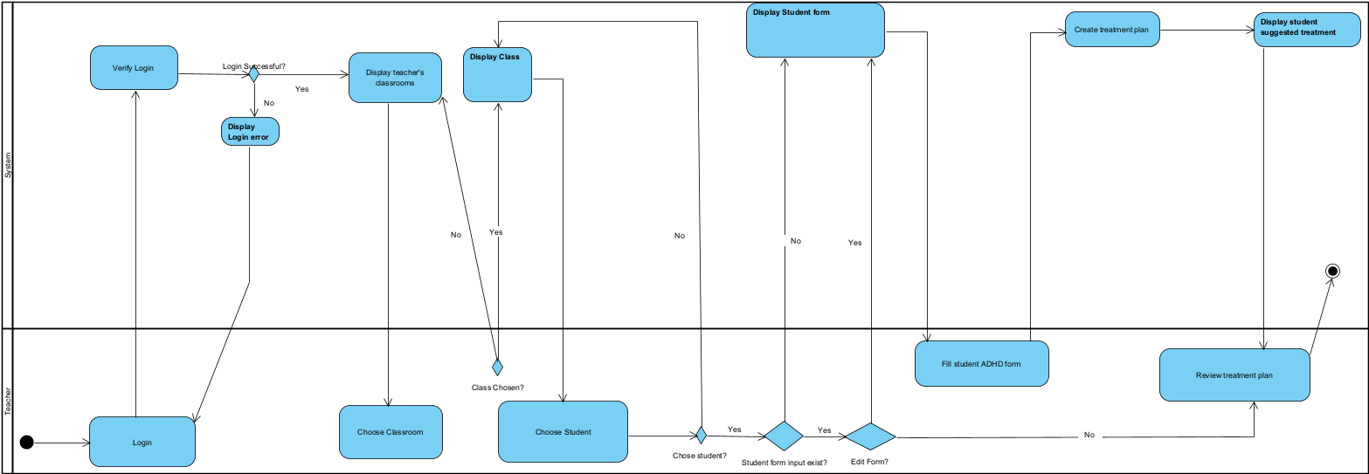
Figure 1.1 ADHD app Activity diagram

Description of the development process
The development process involved creating a comprehensive and user-friendly ADHD management system for teachers.
We began by conducting thorough research in phase A, which included studying scientific literature and developing an Object Process Methodology (OPM) model. Using these insights, we designed an intuitive user interface that allowed teachers to enter data manually or select students from their classes. contributed to the overall success of the project and helped ensure the system's effectiveness and reliability.

Challenges and solutions:

Choosing the Appropriate Framework:
Selecting the right framework for developing the teacher ADHD app was a significant challenge. We needed a framework that we are familiar with and one that provides the necessary functionality, design and scalability to meet the project requirements.
To address this challenge, we conducted thorough research on various frameworks, considering factors such as ease of use, community support, performance, and compatibility with our desired features. We evaluated different options based on these criteria and selected the framework that best suited our needs.

Designing an Effective and User-Friendly System:
Designing the system in a way that strikes a balance between being comprehensive and user-friendly posed a challenge. We needed to ensure that the ADHD form captured essential behavioral aspects while also being intuitive and easy for teachers to navigate.
Additionally, we wanted to provide teachers with more options for data entry, such as allowing them to either enter a student ID directly or choose a student from their class.
To address this challenge, we created an interface that allowed flexible data entry, accommodating manual ID entry and student selection. We enhanced user-friendliness by incorporating icons, tooltips, and descriptive text throughout the form, guiding teachers and making it easier to understand each step.
By offering multiple data entry options and designing an informative interface, we successfully balanced comprehensiveness and user-friendliness. Teachers could navigate and complete the ADHD form effortlessly, ensuring essential behavioral aspects were captured. The intuitive nature of the system, along with informative elements, enhanced the overall user experience and facilitated efficient data entry and navigation.

Ensuring Data Security and Bug Prevention:
Safeguarding sensitive data and preventing potential bugs were critical challenges during the development process. We needed to implement encryption mechanisms for password protection and ensure the validity and consistency of the database.

To address data security concerns, we implemented encryption algorithms to protect sensitive information, such as passwords, stored in the system. Additionally, we conducted thorough testing, including functional and integration testing, to identify and resolve any potential bugs or errors. Validating the database for consistency helped ensure smooth operation and data integrity.

Tools:
Throughout the development process, we utilized various tools and technologies to create the ADHD management system. These tools played a crucial role in different aspects of the system's design, implementation, and deployment. Here are some of the key tools used:
Programming Languages: We utilized HTML, CSS, JavaScript, and jQuery for front-end development. These languages allowed us to design the user interface, implement interactivity, and enhance the visual appeal of the application.
Frameworks and Libraries: We leveraged frameworks and libraries such as Bootstrap and jQuery UI to expedite the development process and ensure consistent design patterns and responsive layouts across different devices.
Database Management: MongoDB was employed as the database management system to store and retrieve data related to students, their forms, system’s output, teacher’s classes and more.
Deployment: The system was deployed using the Heroku platform, which provided an easy and convenient way to host and manage the application in a cloud environment.
Security: To enhance security measures, we implemented password encryption techniques to protect user information and ensure data confidentiality, and features such as google captcha when logging into the system.
Integrated Development Environment (IDE): Visual Studio Code served as the primary IDE for coding, providing a powerful and user-friendly environment for editing, debugging, and collaborating on the project.
Version Control: Git was utilized for version control, allowing multiple developers to collaborate on the project simultaneously, track changes, and manage code repositories effectively.

These tools, along with other supporting technologies, enabled us to efficiently develop and deploy the ADHD management system, ensuring its functionality, usability, and security.

- Acceptance Tests
The acceptance tests aim to verify the functionality and behavior of the ADHD Web Application
These tests ensure that the system operates correctly, displays appropriate error messages, and meets user expectations.
3.1 Test Environment
The tests were conducted using Visual Studio as the development environment.
The web application was deployed on render and it was tested that it runs properly in the deployed environment. The URL for the web application is: https://adhd-web-app.onrender.com/
The MongoDB database was configured and connected to the web application.
3.2 Test Scenarios and Test Cases
Login Functionality:
Test Scenario 1: Valid Teacher Login
Description: Verify that a teacher can successfully log in with valid credentials.
Test Steps:
Open the web app login page.
Enter valid teacher login credentials.
Click the "Login" button.
Expected Result: The teacher should be logged in and redirected to the dashboard page.

Test Scenario 2: Invalid Teacher Login
Description: Verify that appropriate error messages are displayed for invalid teacher login attempts.
Test Steps:
Open the web app login page.
Enter invalid teacher login credentials.
Click the "Login" button.
Expected Result: The system should display an error message indicating the invalid login attempt.
Pupil and Class Management
Test Scenario 1: Pupil Existence Check
Description: Verify that the system checks for the existence of a pupil before displaying their information in the various pupil related activities.
Test Steps:
Log in as a teacher.
Enter “Manage Students”.
Expected Result: If the pupil does not exist, the system should not display him in the list of students under the teacher’s name.
Test Scenario 2: Add Pupil
Description: Verify the form before adding a new pupil to the system.
Test Steps:
Log in as a teacher.
Enter “Add Students”.
Fill in the form for the student
Expected Result: If one of the inputs are invalid, the system should alert the teacher.

Test Scenario 3: Pupil form validation
Description: Verify that the system handles pupil’s form actions appropriately.
Test Steps:
Log in as a teacher.
Enter the “Add Form” section, enter select single/class form, and choose a pupil to begin form for.
Click on Begin form on a given pupil ID.
Expected Result: The system should alert if the form already exists to allow modifications to the form or deletion of the form.
Test Scenario 4: Pupil treatment plan validation
Description: Verify that the system handles operations releated to pupil’s treatment plans appropriately.
Test Steps:
Log in as a teacher.
Enter the “Student Treatment”/”Class Treatment” section, choose a pupil by entering pupil ID, or from picking an ID if chose the Class Treatment option.
Expected Result: The system should display an error message if no treatment plan was found for the given pupil or the pupil doesn’t exist or the class chosen is empty.
3.3 Test Results
All acceptance tests were successfully conducted in both the Visual Studio development environment and the deployed environment. The tests covered essential functionalities such as teacher login validation, student form availability, and appropriate error messaging. All expected results were achieved, confirming the robustness and reliability of the ADHD web app.

Challenges and solutions

Challenges

Formulating Relevant Questions for the ADHD Form:
One of the significant challenges encountered during the project was determining the questions to include in the ADHD form. It was essential to ensure that the questions captured the behavioral aspects and symptoms associated with ADHD accurately.
The challenge lay in finding a balance between comprehensive coverage of ADHD indicators and keeping the form concise and user-friendly for teachers.

Challenge: Determining the "Right" Treatment Options:
Another significant challenge in developing the system was determining the appropriate treatment options for each student based on their ADHD characteristics.
ADHD is a complex disorder with variations in symptoms and severity among individuals.
It was crucial to ensure that the system provided personalized and effective treatment recommendations tailored to each student's unique needs.

Decisions
To address the challenge of formulating relevant and comprehensive questions for the ADHD form, we adopted a multi-faceted approach. In phase A of the project, we conducted extensive research and delved into scientific articles, studies, and literature on ADHD. This research provided us with valuable insights into the behavioral patterns and symptoms commonly observed in individuals with ADHD.
Additionally, we incorporated the Object Process Methodology (OPM) model, which was developed collaboratively by our team and the professor. The OPM model served as a conceptual framework, representing the relationships and interactions between different entities within the system. By aligning the questions with the OPM model, we ensured that the form encompassed essential behavioral aspects and factors relevant to ADHD.
To strike a balance between comprehensiveness and usability, we carefully selected questions that represented a diverse range of behavioral indicators. Our aim was to capture the core symptoms associated with ADHD while avoiding overwhelming teachers with an excessively lengthy form. By synthesizing insights from research, academic resources, and the OPM model, we formulated a set of questions that provided a holistic view of the students' behavioral patterns.
To address the challenge of determining the "right" treatment options, we adopted an evidence-based approach and implemented a scoring system.
We extensively researched proven solutions for different ADHD behaviors, drawing insights from scientific literature, clinical guidelines, and expert opinions.
This evidence-based approach enabled us to incorporate a wide range of effective treatment options into the system's output, ensuring personalized recommendations for each student.
Additionally, we implemented a scoring system that evaluates the student's level of hyperactivity, inattentiveness and impulsivity.
This scoring mechanism reflects the severity or presence of specific ADHD symptoms and guides the selection of appropriate treatment options.
To further enhance accuracy, we also considered additional parameters such as age and gender, which can influence ADHD characteristics. Adjusting for developmental differences and recognizing gender-specific behaviors, we tailored the treatment recommendations to better meet the unique needs of each student.

Teacher Manual: Using the ADHD Management Web Application
The ADHD Management Web Application has been successfully deployed using the Render platform, ensuring convenient access from anywhere. To utilize the application, teachers can simply enter the following URL: https://adhd-web-app.onrender.com/.
  - Key Features
The ADHD Management Web Application offers a range of features to assist teachers in efficiently managing pupil’s and their ADHD. This section highlights key features and provides step-by-step instructions on how to utilize them effectively.
5.1.1 Add Student
To add a new student to the system, follow these steps:
Click on Students and then the 'Add Student' in the sidebar.

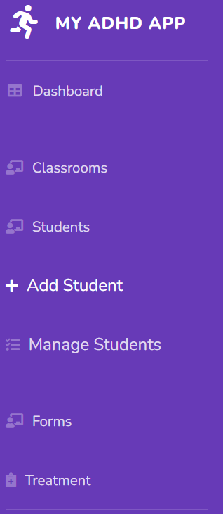
Fill in the required details, be aware that the student ID is a unique field and if a student exists with the same ID you will not be able to add the student.

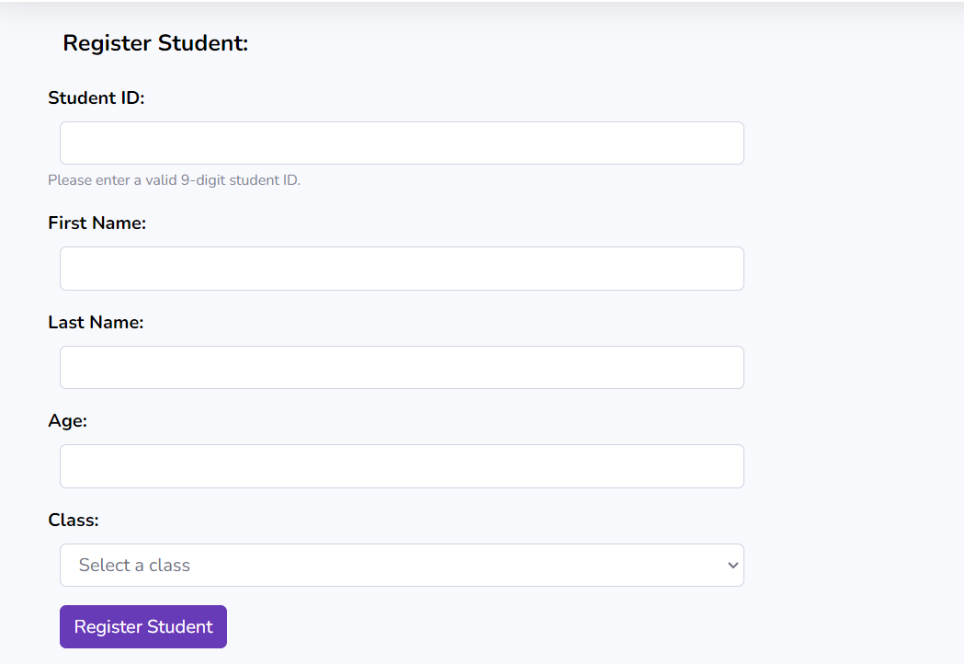
Click the Register Student' button to save the student's information into the system.
5.1.2 Add Class
To create a new class within the system, use the 'Add Class' feature:
In the sidebar, press on Classes and then on ‘Add Class' submenu.
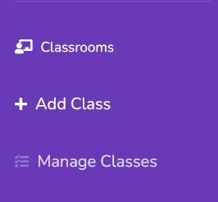
Once inside, you will be asked to provide the class name which is unique field, meaning no two classes may have the same name.

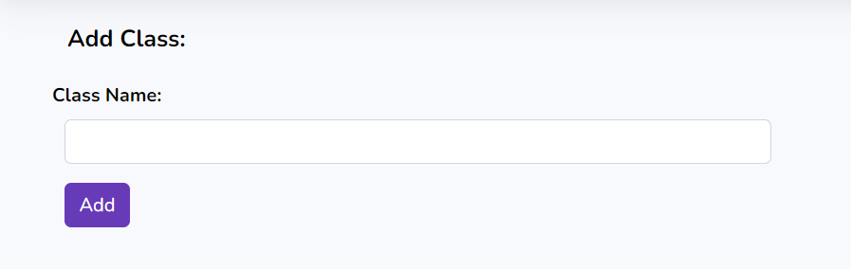

Click the 'Add’ button to save the class.

5.1.3 Manage Class
The 'Manage Class' feature allows teachers to view all the classes they are assigned to, along with their respective details. To access this feature:
Select the 'Manage Class' option in the sidebar.

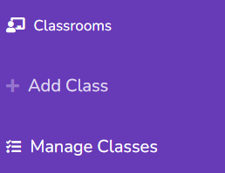
The system will display a list of classes assigned to the given teacher 3 classes per page, along with relevant information, such as class name, class size, and option to delete the class.
If the teacher has more then 3 classes, there is a Next/Previous buttons to navigate back and forth to view the rest of the classes.

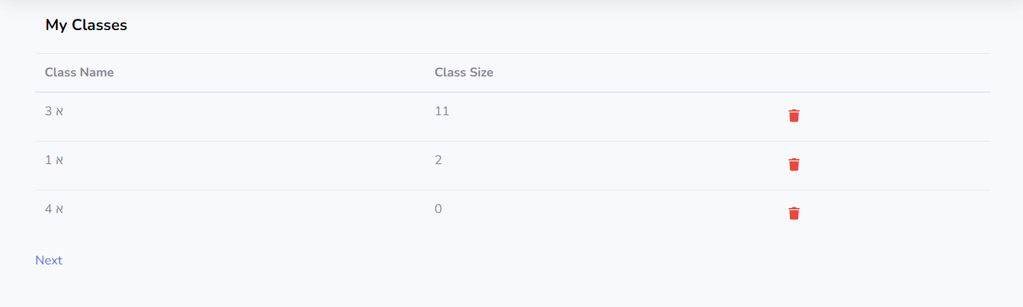

5.1.4 Manage Students
Teachers can utilize the 'Manage Students' functionality to view and manage all the pupils within all of their classes:
To begin, press on ‘Students’ and then on 'Manage Students' submenu in the sidebar.
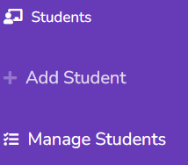
The system will present a comprehensive list of students, including their names, ages, class assigned to, ID, and option to delete the student.
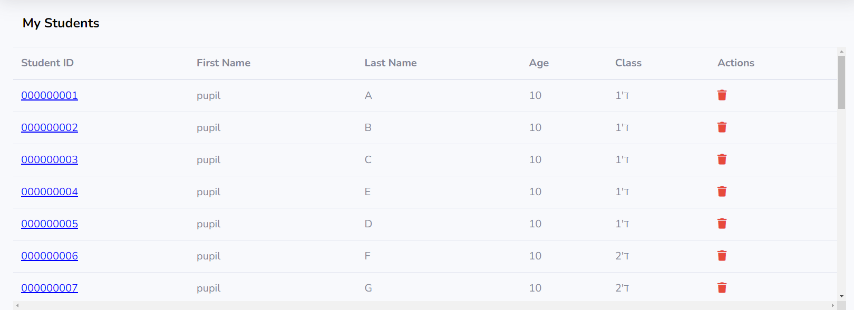Pressing on the Student ID will redirect to the Student Treatment Plan if one exists.

5.1.5 Add Form
The 'Add Form' feature enables teachers to create new forms for students, capturing essential information related to their ADHD management. To utilize this feature:
Click on the ‘Form’ and then ‘Add Form' option in the sidebar.


You will be then be presented with explanation on the form you are about to fill, and be presented with two options:
- Begin Individual Form
- Begin Class Form

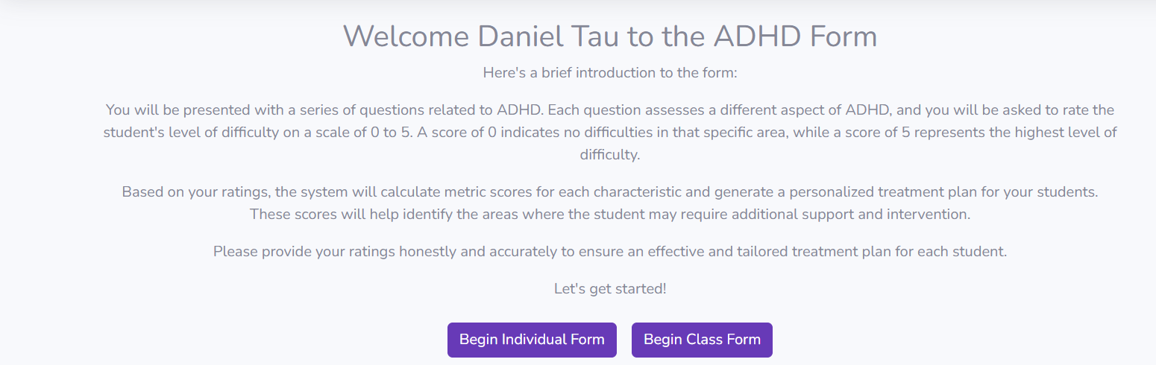

Individual form:
You will be asked to select the student you wish to fill the form for by providing the student ID.

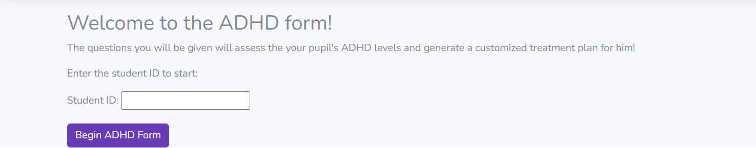
If a valid ID was entered, you will be redirected to the form itself.

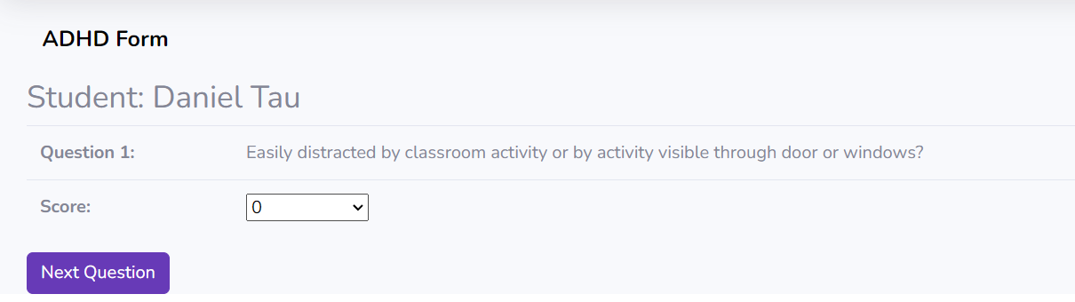

Single form variants:
- If the student ID is invalid an error message will appear.
- If the form already exists then two options will appear – Edit/Delete.
- Pressing ‘Edit’ will load the form with the previous filled answers.
- Pressing ‘Delete’ will delete the form.

Class form:

Here you will be presented with an explanation and will then be asked to pick a class from your assigned classrooms.

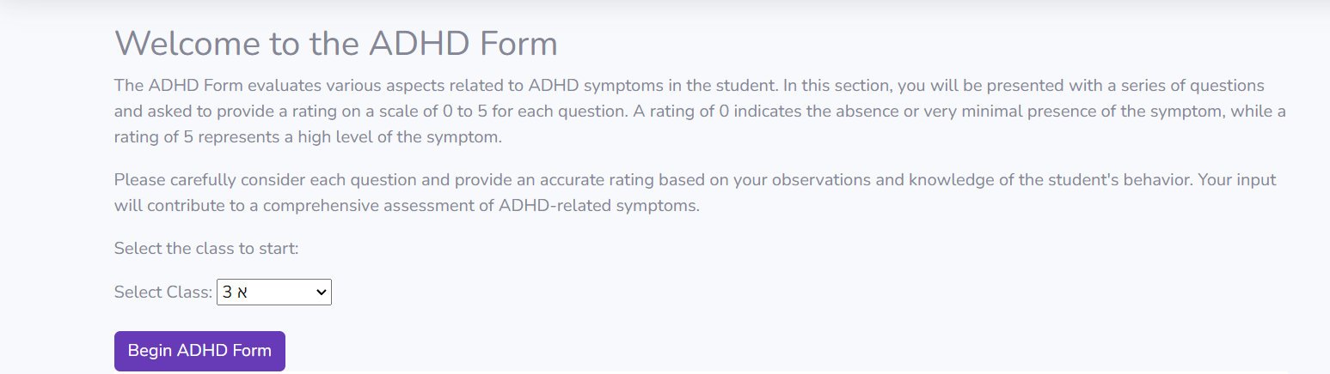
If you choose a classroom that has students in it, you will be presented with a list of students belonging to the chosen classroom.

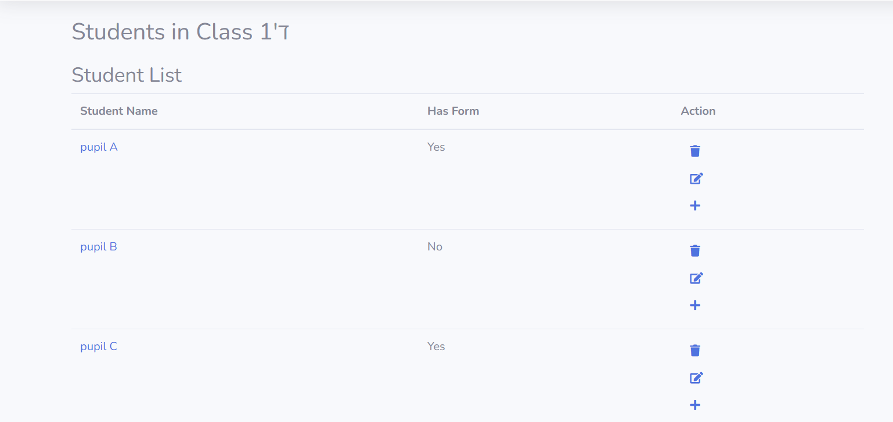

Variants:
- Pressing the student name will trigger a dialogue – if a form already exists, you will be asked if you wish to edit the form, confirming will redirect you to the form with your previous answers loaded. And if there is no form filled yet, you will be asked if you wish to begin a new form.
- The icons are self explanatory , clicking + will add a new form if there isn’t one already. And the next icons are for editing existing form or deleting a form.
- Redirection to form for editing/adding new form will display the student form:

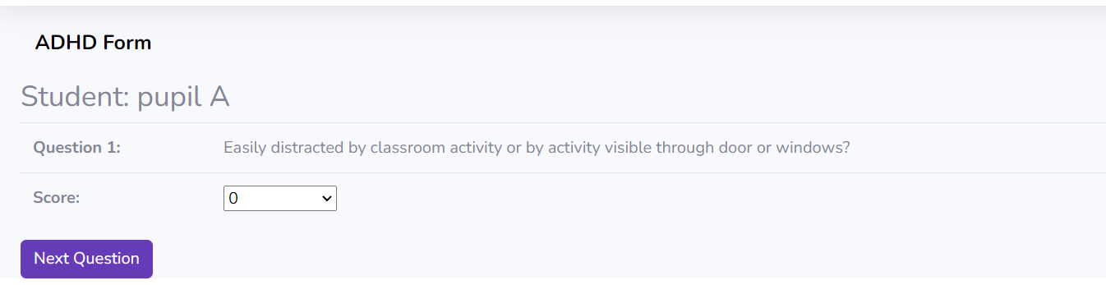

5.1.5 Treatment:

The 'Treatment’ feature enables teachers to view generated treatment plans for their pupils.
To utilize this feature:
Press on ‘Treatment’ in the sidebar and then choose between ‘Student Treatment’ and ‘Class Treatment’.

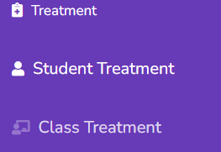

Student Treatment:
You will be asked to select the student you wish to view treatment for by providing the student ID.



Entering a valid ID with a student that a form has been filled for will display the treatment plan after pressing on ‘View treatment plan’

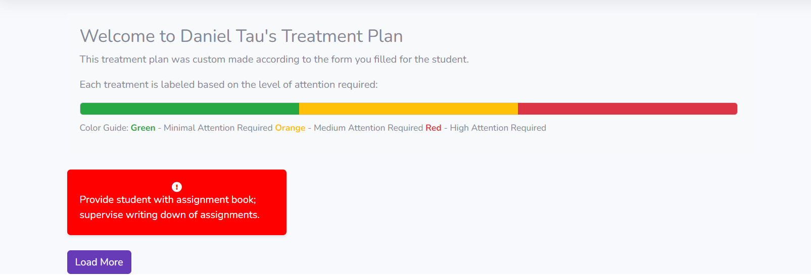
Variants:
- Invalid Student ID or student with no form will trigger an error claiming that the student does not have a treatment plan available.
- Once viewing Treatment Plan, by pressing ‘Load More’ will cause more treatment options (if available) to appear on the screen.
Class Treatment:
By pressing ‘Class Treatment’ the teacher will be asked to choose a class from her available classrooms:

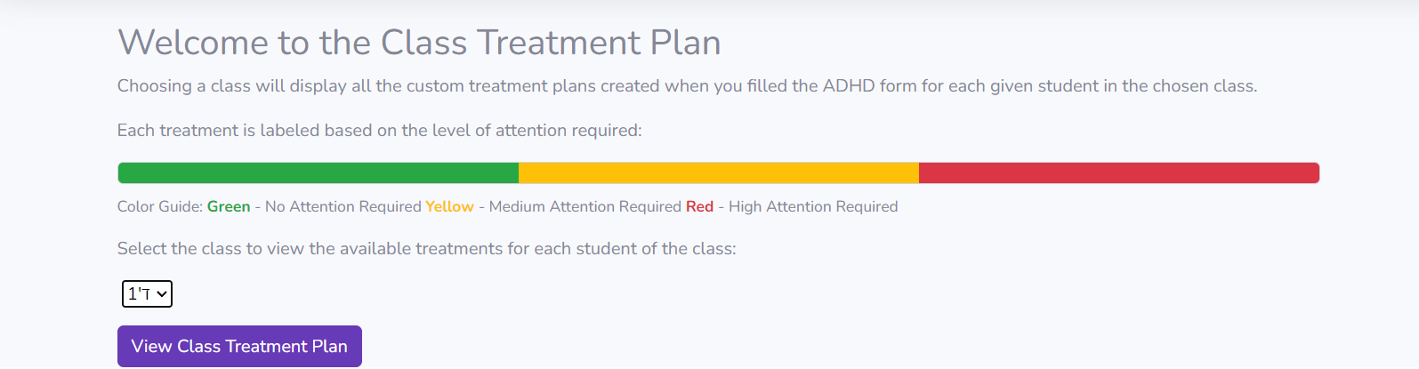

Entering a none empty classroom will redirect to a list of all the pupils from that classroom and their treatment plan

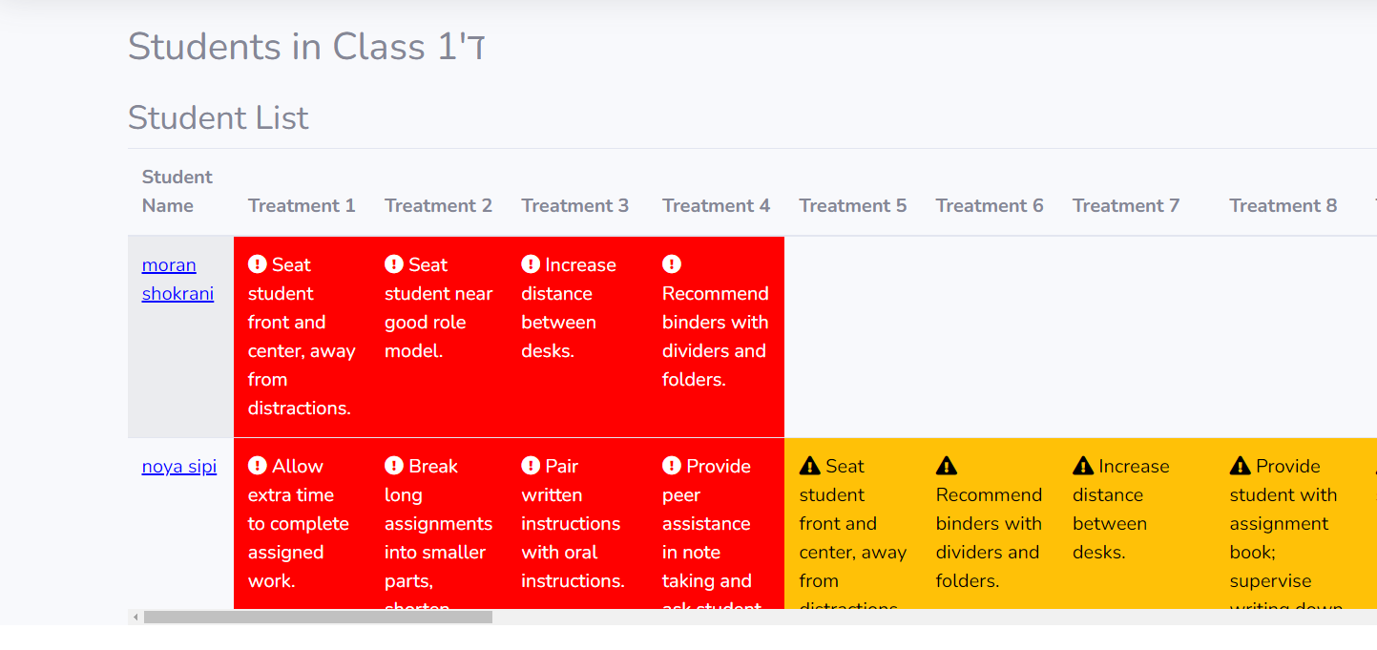
Variants:
- The Treatments displayed are sorted from most urgent to least urgent (red to green).
- Questions that a teacher filled answer of 0 to is translated in the system as no treatment needed and is not presented in the list.
- The list presented will first show the pupils with a treatment plan, and at the bottom of the list will be the pupils with no available treatment plan.
- Pressing on the Student Name will shift the focus to a singular view of the treatment plan as described in Student Treatment.

This covers all the main features of the ADHD web application.
Inside the app you can find other features such as about me page, settings page and more, which require no explanation.

Maintenance guide
To begin this maintenance guide we will first direct you to the readme file in our github which can be found at: https://github.com/DanielTau94/ADHD-web-App/blob/main/README.md .The rest of this guide will assume that you have followed all the instructions found in the README and successfully ran the app in your local machine.
The guide will cover the web-app project from the maintenance standpoint and not a consumer point of view.

Configurations:

The following files contain sensitive information that regards the web application admin information:
- .env – Auth Email and Auth Password for nodeJS
- Keys.js – contains the mongoDB compass URI that is entered in the mongoDB compass.
- About.ejs – this page displays contact information to help the user contact the admin of the app.

Routes:

The routes in this web application can be found in the "views" folder and have 2 main files. These routes handle different HTTP methods, such as POST and GET, to enable various functionalities of the application.

Index Route:
- Location: "views/index"
- Purpose: The index route handles the main page of the application and is responsible for rendering and processing requests related to the homepage.
- HTTP Methods:
- GET: Retrieves and displays the main page content to the user.
- POST: Processes data submitted from forms or other user interactions on the main page.

Users Route:
- Location: "views/users"
- Purpose: The users route manages user-related functionality, such as registration, login, and user profile management.
- HTTP Methods:
- GET: Retrieves and displays user-specific information, such as the user profile or settings page.
- POST: Processes data submitted from forms or other user interactions, such as user registration or login.

As explained above, the key difference is that the users is more responsible for handling database requests releated to input, such as forms, while the index is more responsible of loading the page with the correct inputs.

General utilities and guidelines:
The web application system incorporates general utilities and guidelines to facilitate the addition of new features and ensure consistent development practices. Here are key notes to consider when creating new features:

Routing and Methods:
To create a new feature, you should define the appropriate HTTP methods (GET and/or POST) in the corresponding route file, either in the "index" or "users" route.
Determine the desired functionality and user interactions for the new feature and design the route accordingly.

Layout Structure:
When creating a new page, it is recommended to use the default layout from the dashboard as a starting point.
Copy the layout structure from the dashboard file and include it in your new page file.
The main content of the page you wish to create should be placed between the comments: <!-- Begin Page Content --> and <!-- End Page Content -->.

HTML Page Structure:
Ensure that the HTML elements in your new page follow the established structure and guidelines of the application.
Incorporate relevant HTML tags, classes, and IDs based on the existing design patterns for consistency throughout the system.

CSS Styling:
Apply CSS styling to the new page elements using the existing style sheets.
Utilize the defined classes and styles from the application's CSS files to maintain a cohesive visual appearance.

JavaScript Functionality:
If the new feature requires client-side interactivity or dynamic behavior, consider adding necessary JavaScript functions or event handlers.
Leverage existing JavaScript modules or create new ones to encapsulate and organize the required functionality.

Results and conclusions
In conclusion, the development of the web application system aimed at facilitating the management of pupils with ADHD by educators has been successful. The system has achieved its primary goal of providing educators with a user-friendly web application to effectively manage their pupils with ADHD. Through the input of pupil information and the response to behavioral questions, the system generates tailored treatment options, catering to the specific needs of each pupil.
The implementation of the system, rooted in the Object Process Methodology (OPM) with a focus on ADHD learning, has provided a solid foundation for its functionality. Extensive research and collaboration with a leading doctor in the field of ADHD management have ensured the inclusion of effective treatment options and relevant behavioral questions.
The system's features, including a structured database for data storage and easy access to pupil profiles, behavioral responses, and treatment options, have proven to be valuable assets for educators. The clear guidelines and utilities provided have facilitated the addition of new features and maintained consistency in development practices.
Overall, the web application system has successfully fulfilled its purpose of enabling educators to manage their pupils with ADHD. Its user-friendly interface, tailored treatment options, and efficient data management contribute to a more effective and streamlined approach to supporting pupils with ADHD.
As a future work, we recommend to continue gathering user feedback and refining the system based on the evolving needs of educators and advancements in ADHD management. This will ensure the continued effectiveness and relevance of the web application in supporting educators and enhancing the management of pupils with ADHD.

References

[1] The ADHD Handbook : A Handbook for Parents and Professionals on Attention Deficit Hyperactivity Disorder - Jon Arcelus, Alison Munden.
[2] Sebastian Olbrich, Rik van Dinteren, Martijn Arns. “Personalized Medicine: Review and Perspectives of Promising Baseline EEG Biomarkers in Major Depressive Disorder and Attention Deficit Hyperactivity Disroder”
[3] James M Perrin, Martin T Stein, Robert W Amler, Thomas A Blondis .”Clinical practice guideline: Treatment of the school-aged child with attention deficit hyperactivity disorder”
[4] Hübner, M. “"Personalized Medication Response Prediction for Attention-Deficit Hyperactivity Disorder: Learning in the Model Space vs. Learning in the Data Space"
[5] G.S. Posner and A.S. Brown. "A Review of the Treatment of Attention-Deficit/Hyperactivity Disorder"
[6] M.A. Reiersen and A.T. Volkow. "Technology in the Treatment of Attention-Deficit/Hyperactivity Disorder: A Review"
:

